Portfolio Milestone #1: Bank Marketing Dataset Exploration (SAS Studio)
Nhi Chau
Colorado State University Global
MIS 450
Professor Jordan
January 11, 2026

Introduction
Beginning with the Bank Marketing Dataset (bank.csv) and SAS for the summary stats and graphics for the variables. The variables include each customer’s demographic data, the details of the marketing campaign for each customer, and relevant economic data. The output variable is y (yes/no), which answers whether or not the customer has subscribed to a given term deposit. This is a first pass exploration of the data to help understand the structure of the data and the patterns and distributions to support classification modelling for the final portfolio project (Colorado State University Global, n.d.).
Dataset Upload and Structure SAS (Studio)
The dataset has been successfully uploaded and stored in SAS using the path: WORK.BANK. The dataset has 4,119 records and 21 variables in total, with 21 variables of mixed types, both categorical variables (job, marital, education, housing, loan, contact, month, poutcome, y) and numerical variables (age, duration, campaign, pdays, previous, euribor3m, emp.var.rate, cons.price.idx, cons.conf.idx, nr.employed). This is an important factor at this stage as each of the numerical variables will require summary statistics, and histograms, and each of the categorical variables will require frequency tables and bar charts.
Summary Statistics (Numeric Variables)
Summary statistics for numeric variables are generated using PROC MEANS. Several characteristics of the output are quite noteworthy.
- Age shows typical working-age distribution with values around the middle comprising most of the clients. Since age is not too skewed, it can be seen that mean and median are close to each other.]
- Duration shows large range and high skewness. Since the mean is larger than the median, it can be inferred that the distribution is right-skewed, meaning most calls are short in duration, and that there is a small number of very long calls.
- The variables related to the campaign, namely campaign, pdays, and previous, suggest that many customers have been contacted a small number of times, while a small group of customers have much larger values (potential outliers).
- The economic variables (euribor3m, emp.var.rate, cons.price.idx, cons.conf.idx, nr.employed) are indicators of the market and can be associated with the decision related to subscription.
The summary statistics indicate that the dataset contains a mixture of stable variables (age) and variables such as duration and campaign metrics, which are variable/skewed and may require special consideration for future modeling.
Graphical Summaries
Histogram of Numeric Variables
Histogram is a preferred method to show the distribution of numeric variables. The histogram for age shows that the majority of customers are in a middle age range which supports the summary statistics that age is not very skewed. The duration histogram, however, has a strong right skew, which means most calls are short, but there are a few exceptionally long calls. Such outliers may negatively impact the performance of the model and may need special attention in the analysis.
Bar Charts and Frequencies for Categorical Variables
PROC FREQ and bar charts assisted in summarizing categorical variables. In the frequency tables, several categories overshadow the others (for instance, some job or education levels are more frequent). An important finding is how the target variable y is spread out; this highlights the imbalance present in the data set. The overwhelming majority of the observations record a subscription status of “no,” with a significantly smaller number recording “yes." This is a critical imbalance since it may give the classification models the false appearance of being accurate, interrelating to the majority class. Therefore, the assessment of the models will need to encompass more than just accuracy.
Appropriate Classification Technique
As the response variable y is binary, (yes/no), the valid data mining technique to use for this dataset is classification. A baseline classification model applicable to this dataset is logistic regression, as it predicts the probability of the binary outcome and has interpretations that can be utilized in marketing. It can predict which characteristics of the customer and the campaign will increase the possibility of a subscription. Once more data is available in the later stages of the portfolio, additional classification techniques (like decision trees or random forests) may be used, in the event that additional complexity is present.
Key Data Aspects Identified
From the summary statistics and the various graphs, the following data aspects were deduced:
- The dataset has both categorical and numeric variables, which means that it requires separate techniques for summarization.
- Variables like duration and campaign measures that show extreme values (right skew) and outliers like duration and campaign measures may impact model training.
- Some categorical variables contain the word “unknown”. This can be seen as incomplete data, which can impact the outcome of the predictions.
- The imbalance of classes in y: There are more “no” outcomes than “yes” outcomes, and this should be taken into consideration in the classification evaluation.
This milestone lays the groundwork for the Module 8 portfolio project, where future tasks include the construction of models for anomaly detection, association analyses, clustering of numeric attributes, and classification.

References
Colorado State University Global. (n.d.). Writing Center: APA resources and templates.

APPENDIX A — Screenshots
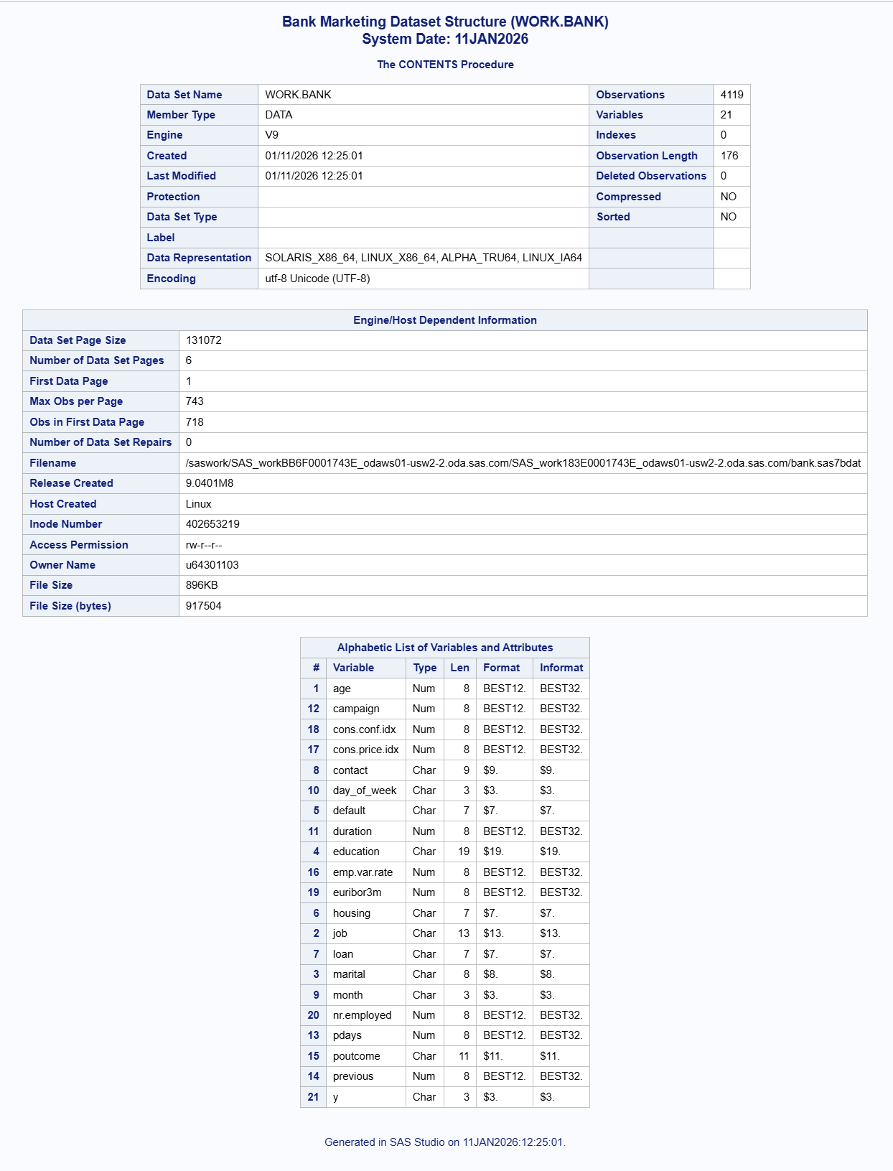Table 1. WORK Library Dataset List Showing WORK.BANK
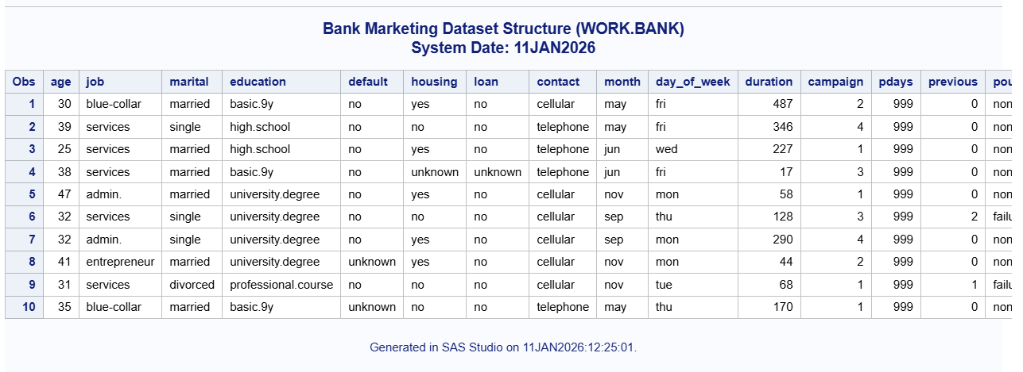
Table 2. PROC CONTENTS Output for Bank Marketing Dataset (WORK.BANK).
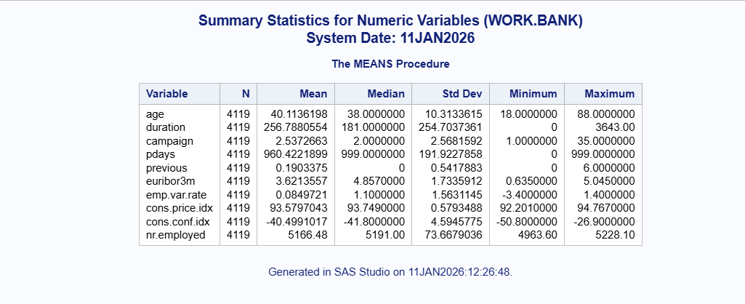
Table 3. PROC MEANS Summary Statistics for Numeric Variables.
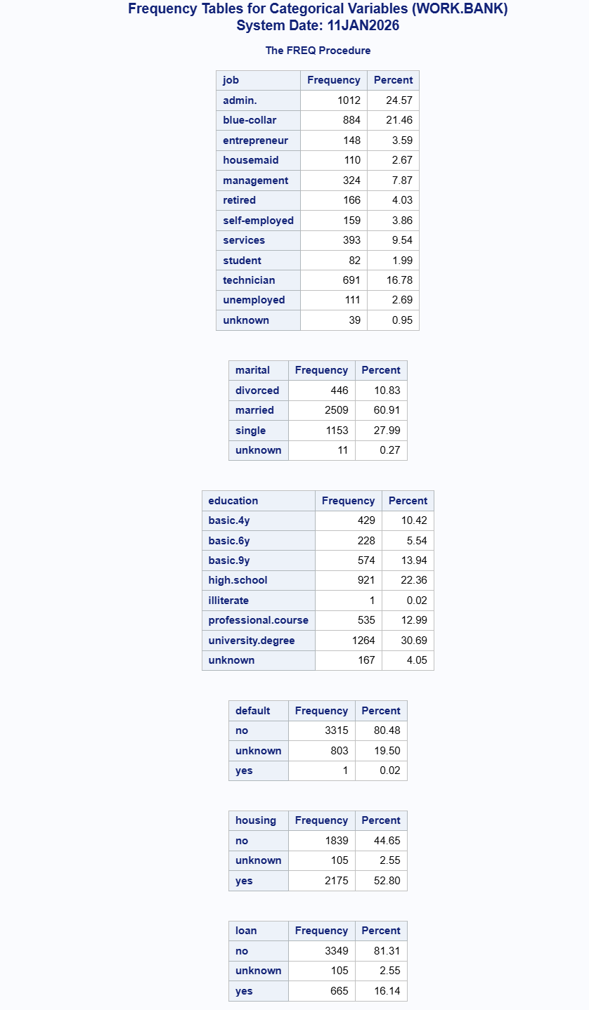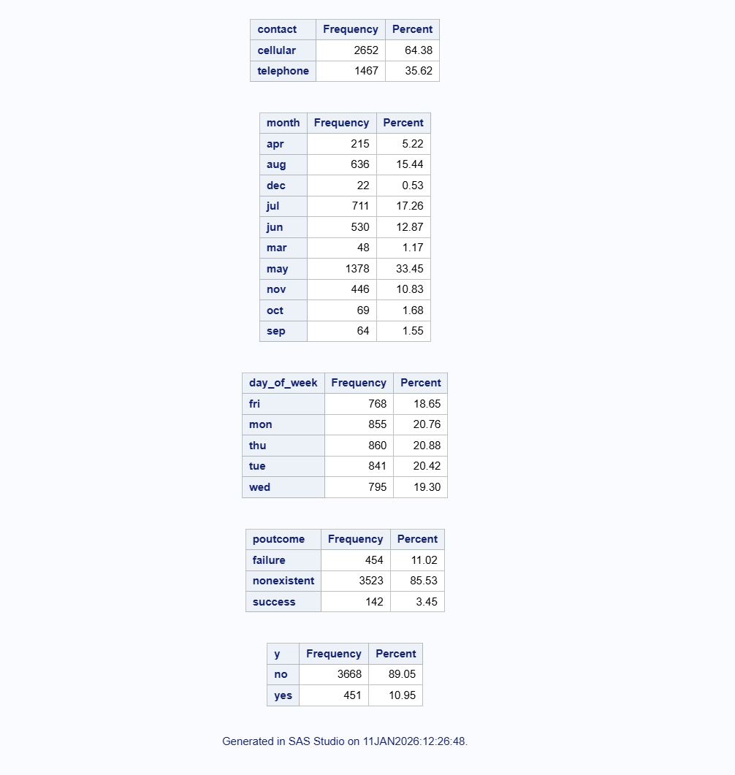
Table 4. PROC FREQ Output for Categorical Variables
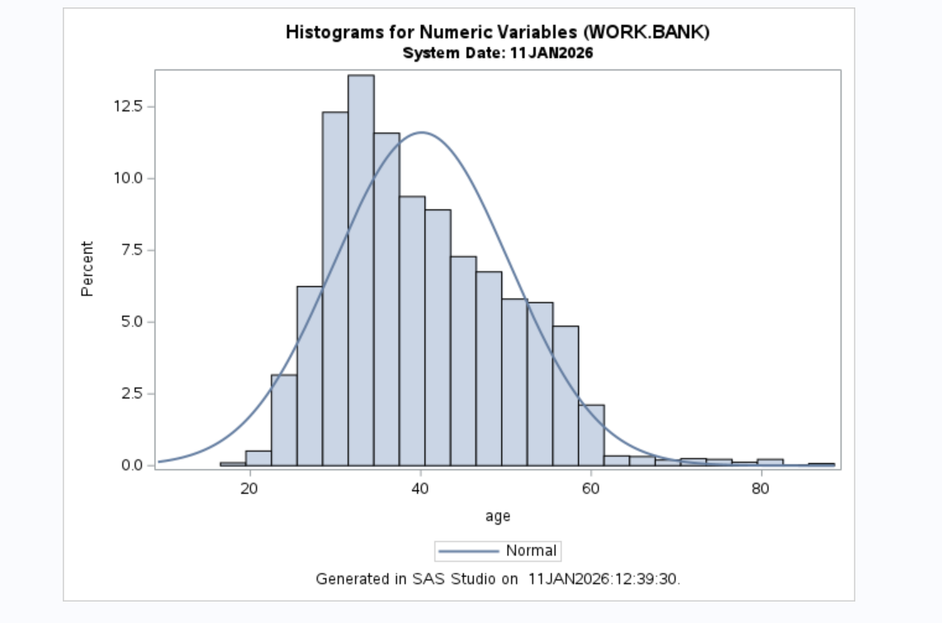
Figure 1. Histogram of Age.
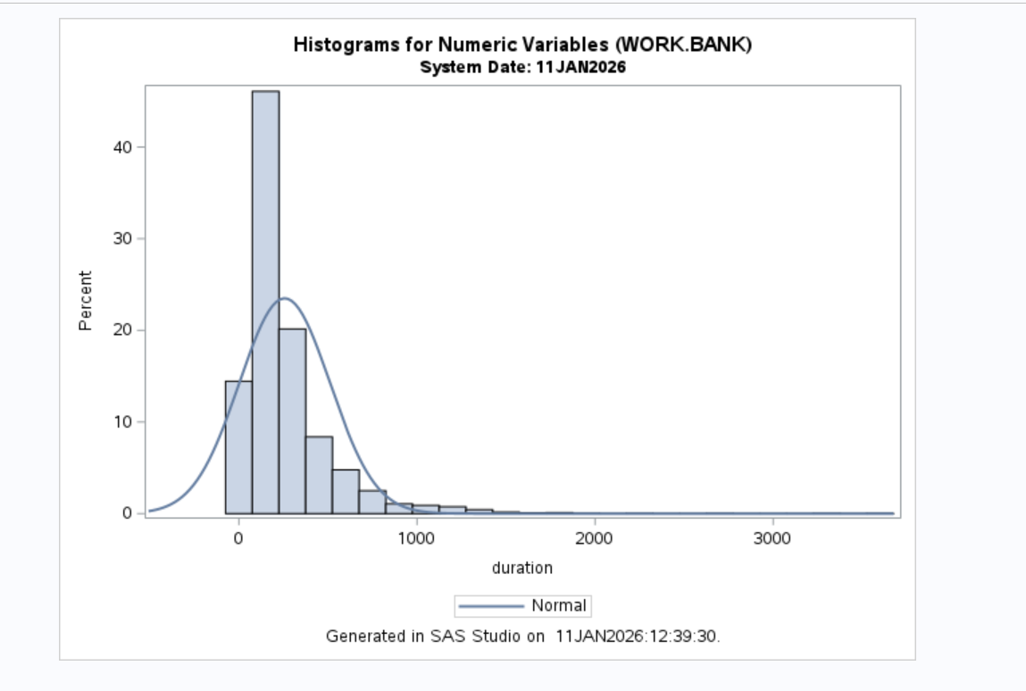
Figure 2. Histogram of Duration.
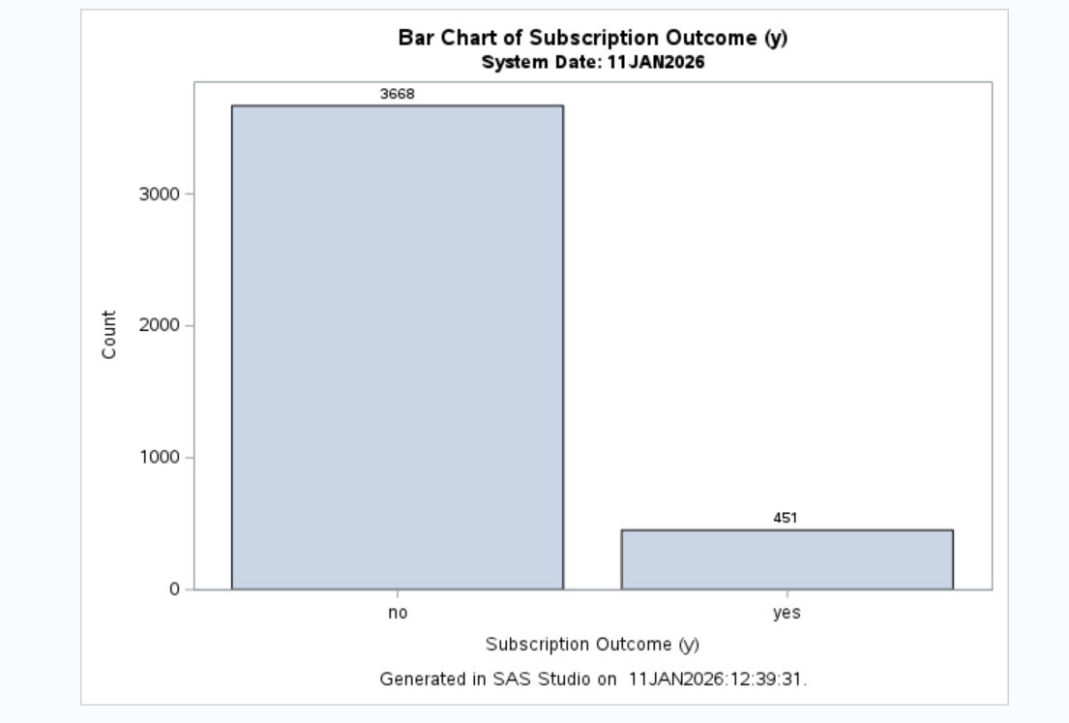
Figure 3. Bar Chart of Subscription Outcome (y).

Appendix B- Code Required
ods graphics on;

/* Always print timestamp on every output */
title1 "Bank Marketing Dataset (WORK.BANK)";
title2 "System Date: %sysfunc(today(), date9.)";
footnote1 "Generated in SAS Studio on %sysfunc(datetime(), datetime19.).";

/* 1) Dataset structure + first 10 rows (categorical + numeric shown) */
proc contents data=work.bank; run;

proc print data=work.bank(obs=10);
run;

/* 2) Summary statistics for ALL numeric variables */
title1 "Summary Statistics for Numeric Variables (WORK.BANK)";
title2 "System Date: %sysfunc(today(), date9.)";
footnote1 "Generated in SAS Studio on %sysfunc(datetime(), datetime19.).";

proc means data=work.bank n mean median std min max;
var age duration campaign pdays previous euribor3m
'emp.var.rate'n 'cons.price.idx'n 'cons.conf.idx'n 'nr.employed'n;
run;

/* 3) Frequency tables for ALL categorical variables */
title1 "Frequency Tables for Categorical Variables (WORK.BANK)";
title2 "System Date: %sysfunc(today(), date9.)";
footnote1 "Generated in SAS Studio on %sysfunc(datetime(), datetime19.).";

proc freq data=work.bank;
tables job marital education default housing loan contact month
day_of_week poutcome y / nocum;
run;

/* 4) Histograms for ALL numeric variables */
title1 "Histograms for Numeric Variables (WORK.BANK)";
title2 "System Date: %sysfunc(today(), date9.)";
footnote1 "Generated in SAS Studio on %sysfunc(datetime(), datetime19.).";

proc sgplot data=work.bank;
histogram age; density age;
run;

proc sgplot data=work.bank;
histogram duration; density duration;
run;

proc sgplot data=work.bank;
histogram campaign; density campaign;
run;

proc sgplot data=work.bank;
histogram pdays; density pdays;
run;

proc sgplot data=work.bank;
histogram previous; density previous;
run;

proc sgplot data=work.bank;
histogram euribor3m; density euribor3m;
run;

proc sgplot data=work.bank;
histogram 'emp.var.rate'n; density 'emp.var.rate'n;
run;

proc sgplot data=work.bank;
histogram 'cons.price.idx'n; density 'cons.price.idx'n;
run;

proc sgplot data=work.bank;
histogram 'cons.conf.idx'n; density 'cons.conf.idx'n;
run;

proc sgplot data=work.bank;
histogram 'nr.employed'n; density 'nr.employed'n;
run;

title; footnote;
ods graphics on;

title1 "Bar Chart of Subscription Outcome (y)";
title2 "System Date: %sysfunc(today(), date9.)";
footnote1 "Generated in SAS Studio on %sysfunc(datetime(), datetime19.).";

proc sgplot data=work.bank;
vbar y / datalabel;
xaxis label="Subscription Outcome (y)";
yaxis label="Count";
run;

title;
footnote;

